NTWAZANGABO Fabrice
29264
Database Development with PL/SQL
ASSIGNMENT1
PART 1: JOINING QUERIES
This Part is about Joining queries using codes provided in Assignment
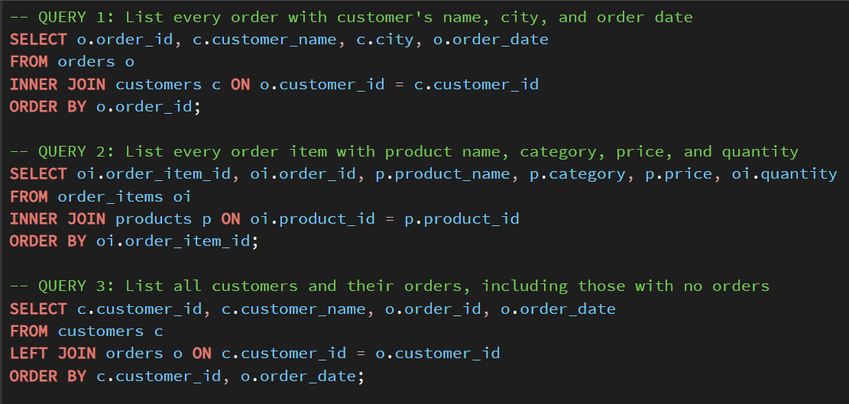
Output:
Here is the Results we got after running those codes
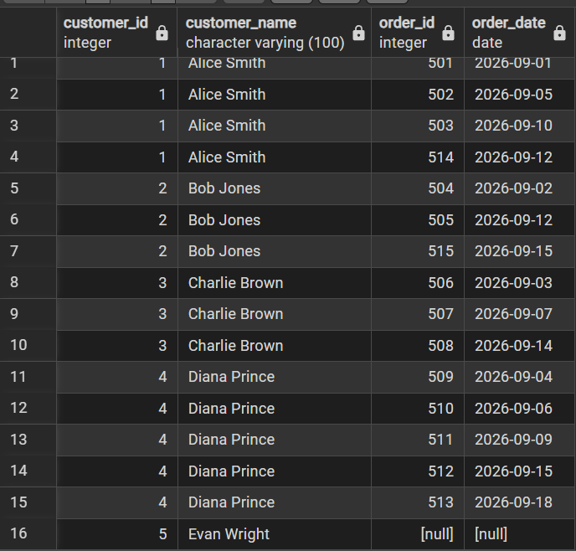

PART 2: CTE QUERY
This part shows calculated Customer’s spending and returns customer’s above average spend by Using CTE
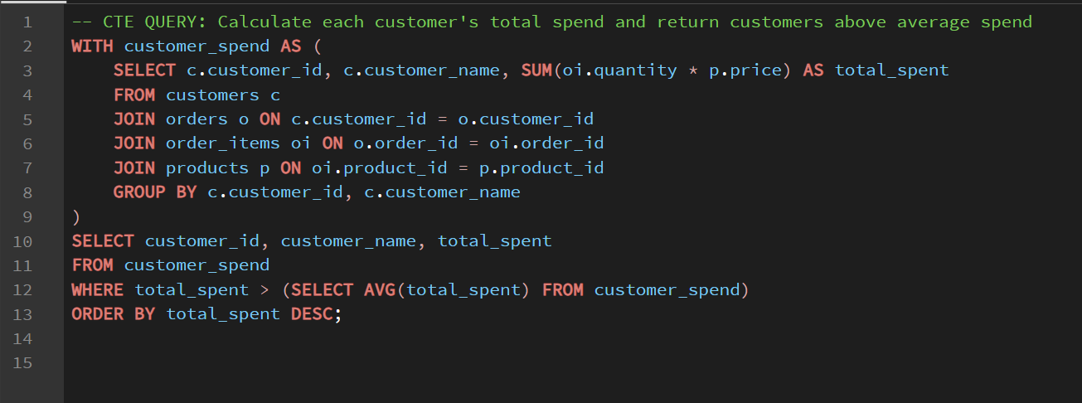
Output: Here Is what we got as a result
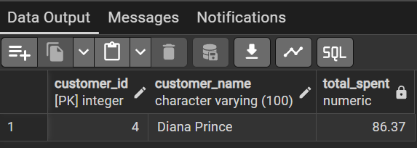
PART 3: WINDOW FUNCTION

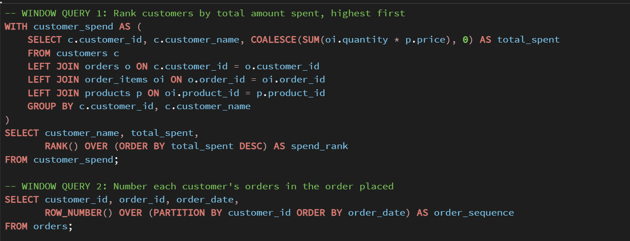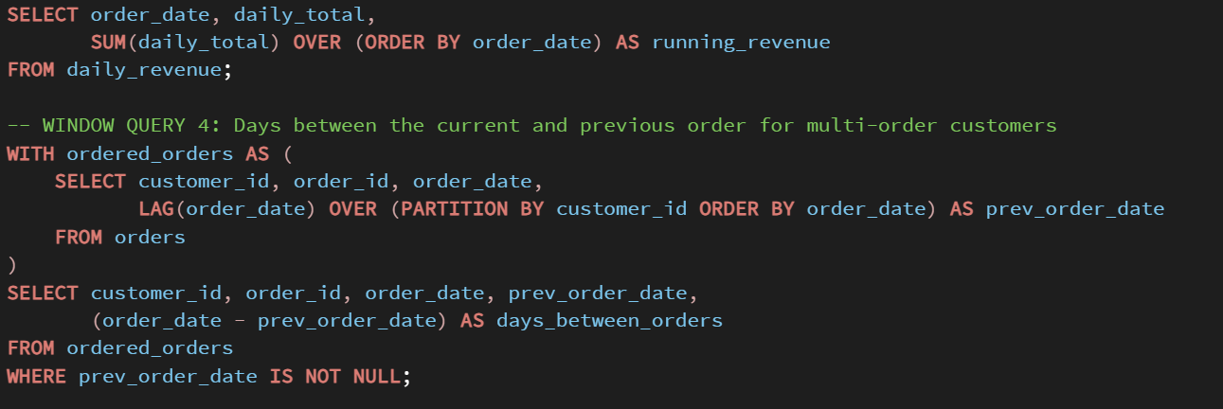
OUTPUT:
